How to Clear Browser Cookies
CHROME BROWSER

- First close all CHROME windows
- Reopen your browser, in the top right corner click the three vertical dots
- Select SETTINGS from drop-down menu
- On the left-hand side, select PRIVACY AND SECURITY
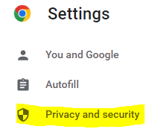
- Select CLEAR BROWSING DATA – CLEAR DATA
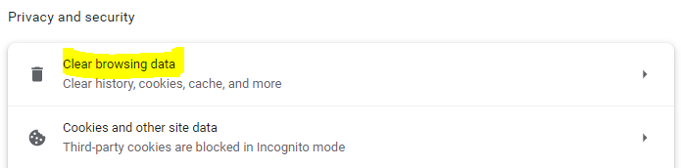
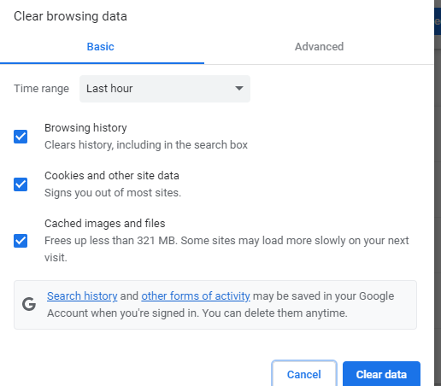
- Once browsing data has been deleted, close your browser and reopen
- You will now be able to access KOG.

MICROSOFT EDGE
- Close all MICROSFOT EDGE windows
- Reopen Browser
- In top right, select (3) Horizontal dots
- Select SETTINGS from drop down menu
- On the left-hand side, select Privacy, Search, and Services
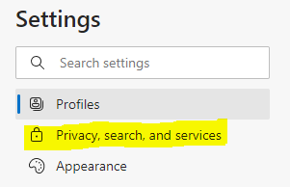
- Scroll to CLEAR BROWSING DATA and click on CHOOSE WHAT TO CLEAR
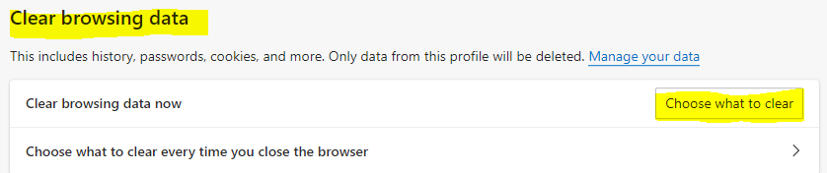
- Select CLEAR NOW
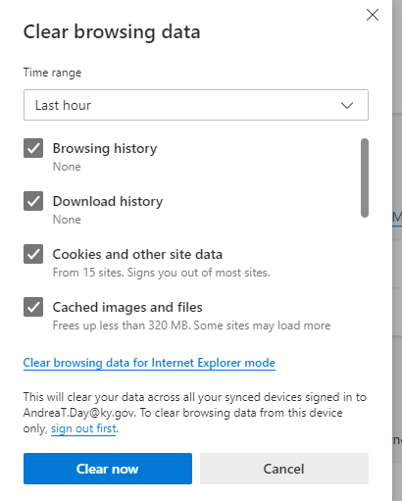
- Once browsing data has been deleted, close your browser and reopen
- You will now be able to access KOG

